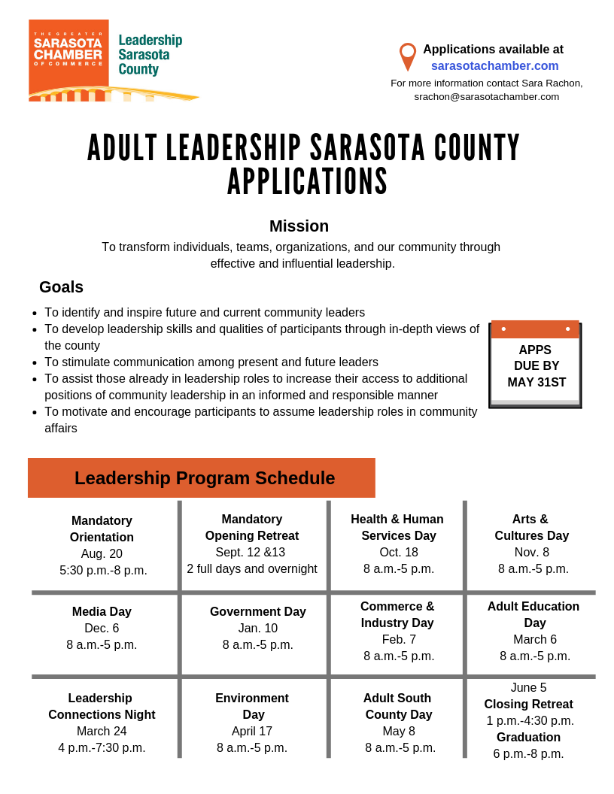
*Attendance is expected at all of the sessions listed above. See Attendance Policy on Page 2.
Program Information:
- All applicants will be notified of status by July 15th, 2019.
- Leadership Sarasota County is committed to having a diverse and dynamic membership.
- Tuition assistance is available for a few qualified applicants.
- Applicants must have the full support of the company or organization by which they are employed.

Instructions/Selection:
- Applications must be submitted on an official application form. Secure a paper form in person at The Greater Sarasota Chamber of Commerce, online (www.sarasotachamber.com), by e-mail [srachon@sarasotachamber.com] or call Leadership Sarasota County at 941-556-4039.
- Limit answers to the space provided.
- ONE letter of recommendation emailed directly to srachon@sarasotachamber.com from author.
- No other attachments will be considered.
- Applications must be fully completed (including receipt of letter of recommendation) and signed by the applicant.
- All applications are subject to a confidential evaluation.
- Interviews will be conducted with all applicants.
- Selected applicants will receive an acceptance letter, after which tuition payment must be made by the appointed date stated in the letter.

Selection Criteria:
The Leadership Sarasota County class shall be selected on the following criteria:
- Individual qualifications and not that of their employer.
- Representation from the greatest breadth of diversity in all socio-economic areas.
- Demonstrated ability to set and achieve personal and professional goals.
- Demonstrated personal commitment to the Sarasota County community and society in general.
- A commitment to the time required by the program.
- A commitment to be a responsible and engaged participant.
- A commitment to participate in producing a “day” for the successive class.
- Announced candidates for public office may not “campaign” and/or use class time to promote their candidacy in any way.

Attendance Policy:
Attendance at all sessions is expected. Attendance at the Orientation and the entire Opening Retreat is MANDATORY to continue the Program. Those who are absent from more than two (2) of the remaining sessions listed on the Program Schedule on page 1 will NOT graduate from the program and will NOT receive a tuition refund. Participation in the Class Project is an additional requirement (schedule varies).

Submission of an application does not guarantee placement.

Candidate Information:

_
Name (last, first, middle) Informal Name Gender

_______________________________________________City_________________Zip________________________________________________
Home Address
Home telephone # Cell Phone #___________________________

Personal e-mail________________________________________

__________________________________________________________________________________________________________________
Employer Employment address (__) Check if this is where you want notices sent

___________________________________________________ ____________________________________
Job Title How many years have you lived in Sarasota?

___________________________________ _______________________________________________________________________
Work Telephone Number Email Address
(Please use the email address you want notices sent to).

____________________________________________
Place of birth

Have you ever applied to Leadership Sarasota County before? ___ Yes ___ No

How (or from whom) did you learn about Leadership Sarasota County?

________________________________________________________________________________________________________________

Shirt Size: ________

Recommendations:

Please list two people, other than your employer, who are knowledgeable about your leadership performance and potential. Your required (one) letter of recommendation may come from one of the individuals listed below. The recommendation needs to come directly to Sara Rachon and not supplied by the Applicant.

________________________________________________________________________________________________________________
Name Business Affiliation Email Telephone

________________________________________________________________________________________________________________
Name Business Affiliation Email Telephone

Commitment:
Tuition for each Chamber member is $1,275. (Non-Chamber member $1525). Once an applicant is selected, payment is due upon the candidate’s affirmation of acceptance.
Limited tuition assistance is available. Do you need tuition assistance in order to participate in the program?
__Yes __ No
If “yes”, complete and return the attached Tuition Assistance Application.

To graduate from the Leadership Sarasota program, participants are expected to attend all sessions (please refer specifically to the Leadership Program Schedule on Page 1) and conduct themselves in a professional manner. Participation in the Class Project is also required. Attendance at the Orientation and the entire Opening Retreat is MANDATORY to continue in the Program. Those who are absent from more than two (2) of the remaining sessions listed on the Program Schedule on Page 1 will NOT graduate from the Program and will NOT receive a tuition refund. Please initial to indicate that you understand these conditions: ______

Employment:

________________________________________________________________________________________________________
Present Employer Type of Business or Organization Date Hired

________________________________________________________________________________________________________
What is your current responsibility with the organization?

________________________________________________________________________________________________________

________________________________________________________________________________________________________
________________________________________________________________________________________________________

________________________________________________________________________________________________________
List of previous employment (5) years in reverse chronological order:

____________________________________________________________________________________________________________________

____________________________________________________________________________________________________________________

____________________________________________________________________________________________________________________

____________________________________________________________________________________________________________________
Education: Begin with highest attained degree.

____________________________________________________________________________________________________________________
School Location Degree Attained
____________________________________________________________________________________________________________________
School Location Degree Attained
____________________________________________________________________________________________________________________
School Location Degree Attained

____________________________________________________________________________________________________________________
List special awards and/or honors:

General Information:
As a member of the Leadership Sarasota County program, you would be required to participate in the Class Project. The concept of the Class Project is to identify and address (in a tangible, long-term & meaningful way) a need in our community. The project will be identified and planned by the members of the class.

Therefore, to jump start this process, identify below THREE topics/problems that are present in Sarasota County and describe how you would tackle/solve/or serve one of these problems if they were ultimately chosen by your classmates to be your Class Project.

What specific skills/knowledge do you hope to gain from your participation in Leadership Sarasota County? What qualities will you bring to the program?

Activity Data:
What has made you the kind of person who cares about our community?

With what volunteer organization/activities are you currently involved? If new to the area, in what have you previously been involved?

___________________________________________________________________________________________________________________
Organization Position/Office

___________________________________________________________________________________________________________________
___________________________________________________________________________________________________________________
___________________________________________________________________________________________________________________
___________________________________________________________________________________________________________________

___________________________________________________________________________________________________________________
Organization Position/Office

___________________________________________________________________________________________________________________
Describe responsibility and/or accomplishments

___________________________________________________________________________________________________________________

___________________________________________________________________________________________________________________
___________________________________________________________________________________________________________________
___________________________________________________________________________________________________________________

___________________________________________________________________________________________________________________
Organization Position/Office

___________________________________________________________________________________________________________________
Describe responsibility and/or accomplishments

___________________________________________________________________________________________________________________
___________________________________________________________________________________________________________________
___________________________________________________________________________________________________________________
___________________________________________________________________________________________________________________

Activity Date (continued)

To date, what do you consider your most significant community contribution in one of these organizations?

Describe one important personal or professional goal you hope to attain within the next five years.

Describe how you have demonstrated a leadership role in your personal and/or professional life.

Approximately, how much time do you devote to community activities each month? _________Briefly explain.

What types of volunteer activities would you like to become involved with in the future?

Is your company a Chamber member? ___ Yes ___ No

Do you know anyone who has participated in Leadership Sarasota County? ___ Yes ___ No If yes, please indicate the person’s name.____________________________________________________________________________________________________

_________________________________________________________________________________________________________

Final checklist:

∙ Application typed or printed with all questions answered?

∙ Application signed and dated?

∙ One letter of recommendation emailed directly to Sara Rachon?

∙ Mail or Deliver To: Leadership Sarasota County, The Greater Sarasota Chamber of Commerce,
1945 Fruitville Road, Sarasota, FL 34236 or email to srachon@sarasotachamber.com.

∙ DEADLINE for receipt of completed application at the Chamber: May 31st, 2019, 12:00p.m.

____________________________________________________________ ___________________________________
Signature Date
Tuition Assistance Application

Explain why you are requesting tuition assistance.

_________________________________________________________________________________________________________
_________________________________________________________________________________________________________
_________________________________________________________________________________________________________
_________________________________________________________________________________________________________
_________________________________________________________________________________________________________
_________________________________________________________________________________________________________
_________________________________________________________________________________________________________
_________________________________________________________________________________________________________
_________________________________________________________________________________________________________

_________________________________________________________________________________________________________
Applicant

______________________________________________________________________________________________________________________
Home Address City State Zip

______________________________________________________________________________________________________________________
Daytime Phone Fax Number Email Address

______________________________________________________________________________________________________________________
Applicant’s Employer

___ Full Time ___ Part Time ___ Hours Per Week

I affirm to the best of my knowledge the above information is true and complete. I agree to provide documentation upon request. I also understand this tuition assistance is only for the Leadership Sarasota County program and is available on a limited basis.

____________________________________________________________ ___________________________________
Full Name Date

